Министерство образования Республики Беларусь

Учреждение образования

«Брестский государственный технический университет»

Кафедра ИИТ

Лабораторная работа №4

за 6 семестр

По дисциплине: «СПП»

Выполнил:

Студент 3 курса

Группы ПО-6(1)

Мартынович Д. М.

Проверил:

Монтик Н.С.

2023

Лабораторная работа №4

**Цель работы:** приобрести практические навыки разработки многооконных приложений на JavaFX для работы с базами данных.

Вариант 11

**Задание:**

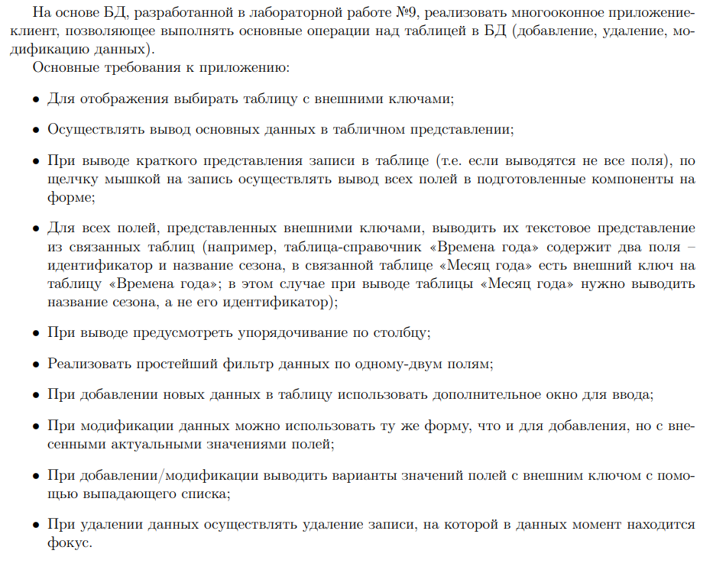

**Код программы:**

**Menu.java**

package laba4;

public class Menu extends javax.swing.JFrame {

public Menu() {

initComponents();

}

@SuppressWarnings("unchecked")

// <editor-fold defaultstate="collapsed" desc="Generated Code">

private void initComponents() {

jPanel1 = new javax.swing.JPanel();

jLabel1 = new javax.swing.JLabel();

jButton1 = new javax.swing.JButton();

jButton2 = new javax.swing.JButton();

jButton3 = new javax.swing.JButton();

jButton4 = new javax.swing.JButton();

jButton5 = new javax.swing.JButton();

jButton6 = new javax.swing.JButton();

jButton7 = new javax.swing.JButton();

setDefaultCloseOperation(javax.swing.WindowConstants.EXIT_ON_CLOSE);

setBackground(new java.awt.Color(255, 255, 255));

jPanel1.setBackground(new java.awt.Color(153, 255, 153));

jPanel1.setBorder(javax.swing.BorderFactory.createBevelBorder(javax.swing.border.BevelBorder.RAISED));

jLabel1.setFont(new java.awt.Font("Tahoma", 1, 40)); // NOI18N

jLabel1.setText("Городской Транспорт");

javax.swing.GroupLayout jPanel1Layout = new javax.swing.GroupLayout(jPanel1);

jPanel1.setLayout(jPanel1Layout);

jPanel1Layout.setHorizontalGroup(

jPanel1Layout.createParallelGroup(javax.swing.GroupLayout.Alignment.LEADING)

.addGroup(jPanel1Layout.createSequentialGroup()

.addContainerGap(36, Short.MAX_VALUE)

.addComponent(jLabel1, javax.swing.GroupLayout.PREFERRED_SIZE, 466, javax.swing.GroupLayout.PREFERRED_SIZE)

.addGap(20, 20, 20))

);

jPanel1Layout.setVerticalGroup(

jPanel1Layout.createParallelGroup(javax.swing.GroupLayout.Alignment.LEADING)

.addGroup(jPanel1Layout.createSequentialGroup()

.addGap(25, 25, 25)

.addComponent(jLabel1, javax.swing.GroupLayout.PREFERRED_SIZE, 43, javax.swing.GroupLayout.PREFERRED_SIZE)

.addContainerGap(22, Short.MAX_VALUE))

);

jButton1.setFont(new java.awt.Font("Tahoma", 1, 20)); // NOI18N

jButton1.setText("Транспорты");

jButton1.setBorder(null);

jButton1.addActionListener(new java.awt.event.ActionListener() {

public void actionPerformed(java.awt.event.ActionEvent evt) {

jButton1ActionPerformed(evt);

}

});

jButton2.setFont(new java.awt.Font("Tahoma", 1, 20)); // NOI18N

jButton2.setText("Маршруты");

jButton2.setBorder(null);

jButton2.addActionListener(new java.awt.event.ActionListener() {

public void actionPerformed(java.awt.event.ActionEvent evt) {

jButton2ActionPerformed(evt);

}

});

jButton3.setFont(new java.awt.Font("Tahoma", 1, 20)); // NOI18N

jButton3.setText("Дата регистрации");

jButton3.setBorder(null);

jButton3.addActionListener(new java.awt.event.ActionListener() {

public void actionPerformed(java.awt.event.ActionEvent evt) {

jButton3ActionPerformed(evt);

}

});

jButton4.setFont(new java.awt.Font("Tahoma", 1, 20)); // NOI18N

jButton4.setText("Время работы");

jButton4.setBorder(null);

jButton4.addActionListener(new java.awt.event.ActionListener() {

public void actionPerformed(java.awt.event.ActionEvent evt) {

jButton4ActionPerformed(evt);

}

});

jButton5.setFont(new java.awt.Font("Tahoma", 1, 20)); // NOI18N

jButton5.setText("Индексы");

jButton5.setBorder(null);

jButton5.addActionListener(new java.awt.event.ActionListener() {

public void actionPerformed(java.awt.event.ActionEvent evt) {

jButton5ActionPerformed(evt);

}

});

jButton6.setFont(new java.awt.Font("Tahoma", 1, 20)); // NOI18N

jButton6.setText("Список");

jButton6.setBorder(null);

jButton6.addActionListener(new java.awt.event.ActionListener() {

public void actionPerformed(java.awt.event.ActionEvent evt) {

jButton6ActionPerformed(evt);

}

});

jButton7.setFont(new java.awt.Font("Tahoma", 1, 20)); // NOI18N

jButton7.setText("Выход");

jButton7.setBorder(null);

jButton7.addActionListener(new java.awt.event.ActionListener() {

public void actionPerformed(java.awt.event.ActionEvent evt) {

jButton7ActionPerformed(evt);

}

});

javax.swing.GroupLayout layout = new javax.swing.GroupLayout(getContentPane());

getContentPane().setLayout(layout);

layout.setHorizontalGroup(

layout.createParallelGroup(javax.swing.GroupLayout.Alignment.LEADING)

.addGroup(javax.swing.GroupLayout.Alignment.TRAILING, layout.createSequentialGroup()

.addContainerGap(javax.swing.GroupLayout.DEFAULT_SIZE, Short.MAX_VALUE)

.addGroup(layout.createParallelGroup(javax.swing.GroupLayout.Alignment.LEADING, false)

.addComponent(jButton7, javax.swing.GroupLayout.DEFAULT_SIZE, javax.swing.GroupLayout.DEFAULT_SIZE, Short.MAX_VALUE)

.addComponent(jButton6, javax.swing.GroupLayout.DEFAULT_SIZE, javax.swing.GroupLayout.DEFAULT_SIZE, Short.MAX_VALUE)

.addComponent(jButton5, javax.swing.GroupLayout.DEFAULT_SIZE, javax.swing.GroupLayout.DEFAULT_SIZE, Short.MAX_VALUE)

.addComponent(jButton4, javax.swing.GroupLayout.DEFAULT_SIZE, javax.swing.GroupLayout.DEFAULT_SIZE, Short.MAX_VALUE)

.addComponent(jButton3, javax.swing.GroupLayout.DEFAULT_SIZE, javax.swing.GroupLayout.DEFAULT_SIZE, Short.MAX_VALUE)

.addComponent(jButton2, javax.swing.GroupLayout.DEFAULT_SIZE, javax.swing.GroupLayout.DEFAULT_SIZE, Short.MAX_VALUE)

.addComponent(jButton1, javax.swing.GroupLayout.PREFERRED_SIZE, 300, javax.swing.GroupLayout.PREFERRED_SIZE))

.addGap(110, 110, 110))

.addComponent(jPanel1, javax.swing.GroupLayout.DEFAULT_SIZE, javax.swing.GroupLayout.DEFAULT_SIZE, Short.MAX_VALUE)

);

layout.setVerticalGroup(

layout.createParallelGroup(javax.swing.GroupLayout.Alignment.LEADING)

.addGroup(layout.createSequentialGroup()

.addComponent(jPanel1, javax.swing.GroupLayout.PREFERRED_SIZE, javax.swing.GroupLayout.DEFAULT_SIZE, javax.swing.GroupLayout.PREFERRED_SIZE)

.addGap(18, 18, Short.MAX_VALUE)

.addComponent(jButton1, javax.swing.GroupLayout.PREFERRED_SIZE, 65, javax.swing.GroupLayout.PREFERRED_SIZE)

.addGap(18, 18, 18)

.addComponent(jButton2, javax.swing.GroupLayout.PREFERRED_SIZE, 65, javax.swing.GroupLayout.PREFERRED_SIZE)

.addGap(27, 27, 27)

.addComponent(jButton3, javax.swing.GroupLayout.PREFERRED_SIZE, 65, javax.swing.GroupLayout.PREFERRED_SIZE)

.addGap(18, 18, 18)

.addComponent(jButton4, javax.swing.GroupLayout.PREFERRED_SIZE, 65, javax.swing.GroupLayout.PREFERRED_SIZE)

.addGap(18, 18, 18)

.addComponent(jButton5, javax.swing.GroupLayout.PREFERRED_SIZE, 65, javax.swing.GroupLayout.PREFERRED_SIZE)

.addGap(18, 18, 18)

.addComponent(jButton6, javax.swing.GroupLayout.PREFERRED_SIZE, 65, javax.swing.GroupLayout.PREFERRED_SIZE)

.addGap(18, 18, 18)

.addComponent(jButton7, javax.swing.GroupLayout.PREFERRED_SIZE, 65, javax.swing.GroupLayout.PREFERRED_SIZE)

.addGap(32, 32, 32))

);

pack();

setLocationRelativeTo(null);

}// </editor-fold>

private void jButton1ActionPerformed(java.awt.event.ActionEvent evt) {

// Транспорты

TranName tn = new TranName();

tn.setVisible(true);

}

private void jButton2ActionPerformed(java.awt.event.ActionEvent evt) {

// Маршруты

Router r = new Router();

r.setVisible(true);

}

private void jButton3ActionPerformed(java.awt.event.ActionEvent evt) {

// Дата регистрации

IntroDate id = new IntroDate();

id.setVisible(true);

}

private void jButton4ActionPerformed(java.awt.event.ActionEvent evt) {

// Время работы

WorkTime wt = new WorkTime();

wt.setVisible(true);

}

private void jButton5ActionPerformed(java.awt.event.ActionEvent evt) {

// Индексы

Indexes i = new Indexes();

i.setVisible(true);

}

private void jButton6ActionPerformed(java.awt.event.ActionEvent evt) {

// Список

Transport t = new Transport();

t.setVisible(true);

}

private void jButton7ActionPerformed(java.awt.event.ActionEvent evt) {

// Выход

System.exit(0);

}

public static void main(String args[]) {

/* Set the Nimbus look and feel */

//<editor-fold defaultstate="collapsed" desc=" Look and feel setting code (optional) ">

/* If Nimbus (introduced in Java SE 6) is not available, stay with the default look and feel.

* For details see http://download.oracle.com/javase/tutorial/uiswing/lookandfeel/plaf.html

*/

try {

for (javax.swing.UIManager.LookAndFeelInfo info : javax.swing.UIManager.getInstalledLookAndFeels()) {

if ("Nimbus".equals(info.getName())) {

javax.swing.UIManager.setLookAndFeel(info.getClassName());

break;

}

}

} catch (ClassNotFoundException ex) {

java.util.logging.Logger.getLogger(Menu.class.getName()).log(java.util.logging.Level.SEVERE, null, ex);

} catch (InstantiationException ex) {

java.util.logging.Logger.getLogger(Menu.class.getName()).log(java.util.logging.Level.SEVERE, null, ex);

} catch (IllegalAccessException ex) {

java.util.logging.Logger.getLogger(Menu.class.getName()).log(java.util.logging.Level.SEVERE, null, ex);

} catch (javax.swing.UnsupportedLookAndFeelException ex) {

java.util.logging.Logger.getLogger(Menu.class.getName()).log(java.util.logging.Level.SEVERE, null, ex);

}

//</editor-fold>

/* Create and display the form */

java.awt.EventQueue.invokeLater(new Runnable() {

public void run() {

new Menu().setVisible(true);

}

});

}

// Variables declaration - do not modify

private javax.swing.JButton jButton1;

private javax.swing.JButton jButton2;

private javax.swing.JButton jButton3;

private javax.swing.JButton jButton4;

private javax.swing.JButton jButton5;

private javax.swing.JButton jButton6;

private javax.swing.JButton jButton7;

private javax.swing.JLabel jLabel1;

private javax.swing.JPanel jPanel1;

// End of variables declaration

}

**Transport.java**

package laba4;

import java.sql.*;

import java.util.Arrays;

import java.util.Vector;

import java.util.logging.Level;

import java.util.logging.Logger;

import javax.swing.JOptionPane;

import javax.swing.table.DefaultTableModel;

public class Transport extends javax.swing.JFrame {

public Transport() {

initComponents();

Connect();

Load();

}

Connection conn;

Statement s;

PreparedStatement pst;

ResultSet rs;

DefaultTableModel d;

public void Connect()

{

try

{

Class.forName("com.mysql.jdbc.Driver");

conn = DriverManager.getConnection("jdbc:mysql://localhost:3306/citytransport","root","root");

} catch (ClassNotFoundException ex) {

Logger.getLogger(Transport.class.getName()).log(Level.SEVERE, null, ex);

} catch (SQLException ex) {

Logger.getLogger(Transport.class.getName()).log(Level.SEVERE, null, ex);

}

}

public void Load()

{

try

{

pst = conn.prepareStatement("select * from transport");

rs = pst.executeQuery();

ResultSetMetaData rsd = rs.getMetaData();

int c = rsd.getColumnCount();

d = (DefaultTableModel)jTable1.getModel();

d.setRowCount(0);

while(rs.next())

{

Vector v = new Vector();

for(int i = 0; i <= c; i++)

{

v.add(rs.getString("id_t"));

v.add(rs.getString("name"));

v.add(rs.getString("number"));

v.add(rs.getString("count"));

v.add(rs.getString("starttime"));

v.add(rs.getString("endtime"));

v.add(rs.getString("datareg"));

v.add(rs.getString("startmar"));

v.add(rs.getString("endmar"));

}

d.addRow(v);

}

} catch (SQLException ex) {

Logger.getLogger(Transport.class.getName()).log(Level.SEVERE, null, ex);

}

}

@SuppressWarnings("unchecked")

// <editor-fold defaultstate="collapsed" desc="Generated Code">

private void initComponents() {

jLabel1 = new javax.swing.JLabel();

jButton1 = new javax.swing.JButton();

jButton3 = new javax.swing.JButton();

jScrollPane1 = new javax.swing.JScrollPane();

jTable1 = new javax.swing.JTable();

jButton2 = new javax.swing.JButton();

jButton5 = new javax.swing.JButton();

setDefaultCloseOperation(javax.swing.WindowConstants.EXIT_ON_CLOSE);

setBackground(new java.awt.Color(0, 0, 0));

jLabel1.setFont(new java.awt.Font("Tahoma", 1, 40)); // NOI18N

jLabel1.setText("Регистрация транспорта");

jButton1.setBackground(new java.awt.Color(255, 153, 153));

jButton1.setFont(new java.awt.Font("Tahoma", 1, 13)); // NOI18N

jButton1.setText("Добавить");

jButton1.setToolTipText("");

jButton1.addActionListener(new java.awt.event.ActionListener() {

public void actionPerformed(java.awt.event.ActionEvent evt) {

jButton1ActionPerformed(evt);

}

});

jButton3.setBackground(new java.awt.Color(255, 153, 153));

jButton3.setFont(new java.awt.Font("Tahoma", 1, 13)); // NOI18N

jButton3.setText("Удалить");

jButton3.addActionListener(new java.awt.event.ActionListener() {

public void actionPerformed(java.awt.event.ActionEvent evt) {

jButton3ActionPerformed(evt);

}

});

jTable1.setModel(new javax.swing.table.DefaultTableModel(

new Object [][] {

},

new String [] {

"ID", "Название", "Номер", "Стоимость", "НачалоРаб", "КонецРаб", "ДатаРег", "НачалоМар", "КонецМар"

}

));

jTable1.addMouseListener(new java.awt.event.MouseAdapter() {

public void mouseClicked(java.awt.event.MouseEvent evt) {

jTable1MouseClicked(evt);

}

});

jScrollPane1.setViewportView(jTable1);

jButton2.setBackground(new java.awt.Color(255, 153, 153));

jButton2.setFont(new java.awt.Font("Tahoma", 1, 13)); // NOI18N

jButton2.setText("Очистить");

jButton2.setToolTipText("");

jButton2.addActionListener(new java.awt.event.ActionListener() {

public void actionPerformed(java.awt.event.ActionEvent evt) {

jButton2ActionPerformed(evt);

}

});

jButton5.setBackground(new java.awt.Color(255, 255, 255));

jButton5.setFont(new java.awt.Font("Tahoma", 1, 13)); // NOI18N

jButton5.setText("Назад");

jButton5.addActionListener(new java.awt.event.ActionListener() {

public void actionPerformed(java.awt.event.ActionEvent evt) {

jButton5ActionPerformed(evt);

}

});

javax.swing.GroupLayout layout = new javax.swing.GroupLayout(getContentPane());

getContentPane().setLayout(layout);

layout.setHorizontalGroup(

layout.createParallelGroup(javax.swing.GroupLayout.Alignment.LEADING)

.addGroup(layout.createSequentialGroup()

.addGroup(layout.createParallelGroup(javax.swing.GroupLayout.Alignment.LEADING)

.addGroup(layout.createSequentialGroup()

.addGap(58, 58, 58)

.addComponent(jLabel1, javax.swing.GroupLayout.PREFERRED_SIZE, 529, javax.swing.GroupLayout.PREFERRED_SIZE)

.addPreferredGap(javax.swing.LayoutStyle.ComponentPlacement.RELATED)

.addComponent(jButton1)

.addGap(18, 18, 18)

.addComponent(jButton2)

.addGap(18, 18, 18)

.addComponent(jButton3, javax.swing.GroupLayout.PREFERRED_SIZE, 89, javax.swing.GroupLayout.PREFERRED_SIZE)

.addGap(18, 18, 18)

.addComponent(jButton5, javax.swing.GroupLayout.PREFERRED_SIZE, 95, javax.swing.GroupLayout.PREFERRED_SIZE))

.addGroup(layout.createSequentialGroup()

.addGap(34, 34, 34)

.addComponent(jScrollPane1, javax.swing.GroupLayout.PREFERRED_SIZE, 998, javax.swing.GroupLayout.PREFERRED_SIZE)))

.addContainerGap(64, Short.MAX_VALUE))

);

layout.setVerticalGroup(

layout.createParallelGroup(javax.swing.GroupLayout.Alignment.LEADING)

.addGroup(layout.createSequentialGroup()

.addContainerGap()

.addGroup(layout.createParallelGroup(javax.swing.GroupLayout.Alignment.LEADING)

.addGroup(layout.createSequentialGroup()

.addGap(6, 6, 6)

.addComponent(jLabel1, javax.swing.GroupLayout.PREFERRED_SIZE, 35, javax.swing.GroupLayout.PREFERRED_SIZE))

.addGroup(layout.createParallelGroup(javax.swing.GroupLayout.Alignment.BASELINE)

.addComponent(jButton3, javax.swing.GroupLayout.PREFERRED_SIZE, 50, javax.swing.GroupLayout.PREFERRED_SIZE)

.addComponent(jButton1, javax.swing.GroupLayout.PREFERRED_SIZE, 50, javax.swing.GroupLayout.PREFERRED_SIZE)

.addComponent(jButton2, javax.swing.GroupLayout.PREFERRED_SIZE, 50, javax.swing.GroupLayout.PREFERRED_SIZE))

.addComponent(jButton5, javax.swing.GroupLayout.Alignment.TRAILING, javax.swing.GroupLayout.DEFAULT_SIZE, javax.swing.GroupLayout.DEFAULT_SIZE, Short.MAX_VALUE))

.addGap(18, 18, 18)

.addComponent(jScrollPane1, javax.swing.GroupLayout.PREFERRED_SIZE, 415, javax.swing.GroupLayout.PREFERRED_SIZE)

.addContainerGap(30, Short.MAX_VALUE))

);

pack();

setLocationRelativeTo(null);

}// </editor-fold>

private void jButton1ActionPerformed(java.awt.event.ActionEvent evt) {

// Добавить

try

{

String sql = "select count(*) from router";

s = conn.createStatement();

ResultSet ress = s.executeQuery(sql);

int count = 0;

while(ress.next()){

count = ress.getInt(1);

}

String sql_sel2 = "select countproezd, datareg from dataintro";

s = conn.createStatement();

ResultSet res2 = s.executeQuery(sql_sel2);

double coun = 0;

String datareg;

double[] c = new double[count];

String[] dat = new String[count];

int j = 0;

while (res2.next()){

coun = res2.getInt("countproezd");

c[j] = coun;

datareg = res2.getString("datareg");

dat[j] = datareg;

j++;

}

System.out.println("count: " + Arrays.toString(c));

System.out.println("datareg: " + Arrays.toString(dat));

String sql_sel3 = "select startmar, endmar from router";

s = conn.createStatement();

ResultSet res3 = s.executeQuery(sql_sel3);

String startmar;

String endmar;

String[] sm = new String[count];

String[] em = new String[count];

int l = 0;

while (res3.next()){

startmar = res3.getString("startmar");

sm[l] = startmar;

endmar = res3.getString("endmar");

em[l] = endmar;

l++;

}

System.out.println("startmar: " + Arrays.toString(sm));

System.out.println("endmar: " + Arrays.toString(em));

String sql_sel4 = "select starttime, endtime from worktime";

s = conn.createStatement();

ResultSet res4 = s.executeQuery(sql_sel4);

String starttime;

String endtime;

String[] st = new String[count];

String[] et = new String[count];

int q = 0;

while (res4.next()){

starttime = res4.getString("starttime");

st[q] = starttime;

endtime = res4.getString("endtime");

et[q] = endtime;

q++;

}

System.out.println("starttime: " + Arrays.toString(st));

System.out.println("endtime: " + Arrays.toString(et));

String sql_sel5 = "select name, number from tranname";

s = conn.createStatement();

ResultSet res5 = s.executeQuery(sql_sel5);

String name;

int number;

String[] n = new String[count];

int[] num = new int[count];

int w = 0;

while (res5.next()){

name = res5.getString("name");

n[w] = name;

number = res5.getInt("number");

num[w] = number;

w++;

}

System.out.println("name: " + Arrays.toString(n));

System.out.println("number: " + Arrays.toString(num));

int k = 0;

for(int p = 0; p < count; p++){

pst = conn.prepareStatement("insert into transport(name, number, count, starttime, endtime, datareg, startmar, endmar) values(?,?,?,?,?,?,?,?)");

pst.setString(1, n[p]);

pst.setInt(2, num[p]);

pst.setDouble(3, c[p]);

pst.setString(4, st[p]);

pst.setString(5, et[p]);

pst.setString(6, dat[p]);

pst.setString(7, sm[p]);

pst.setString(8, em[p]);

k = pst.executeUpdate();

}

if(k > 0)

{

JOptionPane.showMessageDialog(this, "Данные успешно добавлены");

Load();

}

else

{

JOptionPane.showMessageDialog(this, "Ошибка, не удалось добавить данные");

}

} catch (SQLException ex) {

Logger.getLogger(Transport.class.getName()).log(Level.SEVERE, null, ex);

}

}

private void jButton3ActionPerformed(java.awt.event.ActionEvent evt) {

// Удалить

try

{

d = (DefaultTableModel)jTable1.getModel();

int selectIndex = jTable1.getSelectedRow();

String id = d.getValueAt(selectIndex, 0).toString();

pst = conn.prepareStatement("delete from transport where id_t=?");

pst.setString(1, id);

int k = pst.executeUpdate();

if(k == 1)

{

JOptionPane.showMessageDialog(this, "Данные успешно удалены");

jButton1.setEnabled(true);

Load();

}

else

{

JOptionPane.showMessageDialog(this, "Ошибка, не удалось удалить данные");

}

} catch (SQLException ex) {

Logger.getLogger(Transport.class.getName()).log(Level.SEVERE, null, ex);

}

}

private void jTable1MouseClicked(java.awt.event.MouseEvent evt) {

// Удаление по клику на мышку

d = (DefaultTableModel)jTable1.getModel();

int selectIndex = jTable1.getSelectedRow();

String id = d.getValueAt(selectIndex, 0).toString();

}

private void jButton2ActionPerformed(java.awt.event.ActionEvent evt) {

// Очистить

try

{

d.setRowCount(0);

pst = conn.prepareStatement("delete from transport");

int k = pst.executeUpdate();

JOptionPane.showMessageDialog(this, "Данные успешно удалены");

}catch (SQLException ex) {

Logger.getLogger(Transport.class.getName()).log(Level.SEVERE, null, ex);

}

}

private void jButton5ActionPerformed(java.awt.event.ActionEvent evt) {

// Назад

this.setVisible(false);

}

public static void main(String args[]) {

try {

for (javax.swing.UIManager.LookAndFeelInfo info : javax.swing.UIManager.getInstalledLookAndFeels()) {

if ("Nimbus".equals(info.getName())) {

javax.swing.UIManager.setLookAndFeel(info.getClassName());

break;

}

}

} catch (ClassNotFoundException ex) {

java.util.logging.Logger.getLogger(Transport.class.getName()).log(java.util.logging.Level.SEVERE, null, ex);

} catch (InstantiationException ex) {

java.util.logging.Logger.getLogger(Transport.class.getName()).log(java.util.logging.Level.SEVERE, null, ex);

} catch (IllegalAccessException ex) {

java.util.logging.Logger.getLogger(Transport.class.getName()).log(java.util.logging.Level.SEVERE, null, ex);

} catch (javax.swing.UnsupportedLookAndFeelException ex) {

java.util.logging.Logger.getLogger(Transport.class.getName()).log(java.util.logging.Level.SEVERE, null, ex);

}

java.awt.EventQueue.invokeLater(new Runnable() {

public void run() {

new Transport().setVisible(true);

}

});

}

// Variables declaration - do not modify

private javax.swing.JButton jButton1;

private javax.swing.JButton jButton2;

private javax.swing.JButton jButton3;

private javax.swing.JButton jButton5;

private javax.swing.JLabel jLabel1;

private javax.swing.JScrollPane jScrollPane1;

private javax.swing.JTable jTable1;

// End of variables declaration

}

**Результат программы:**

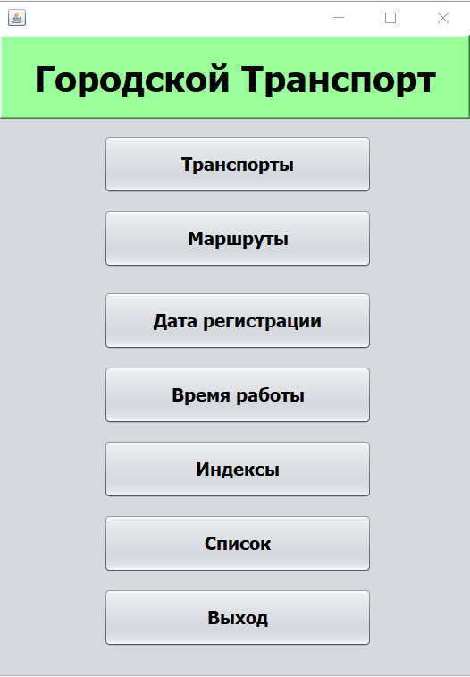

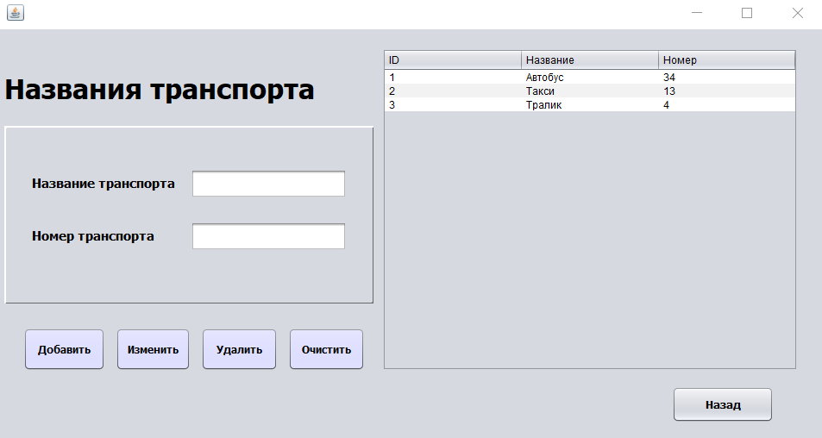

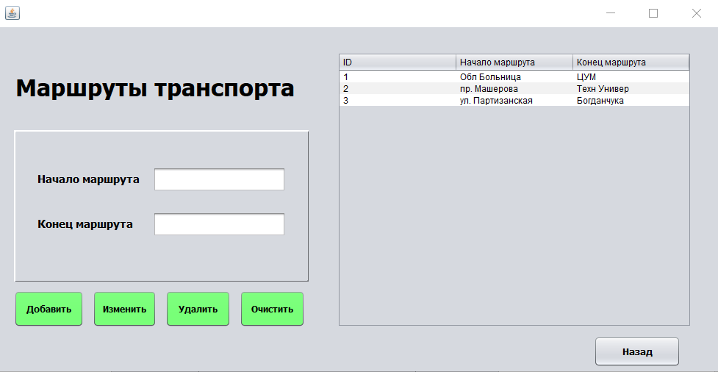

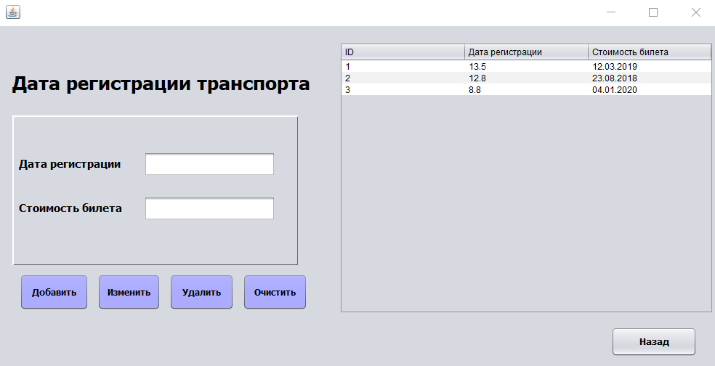

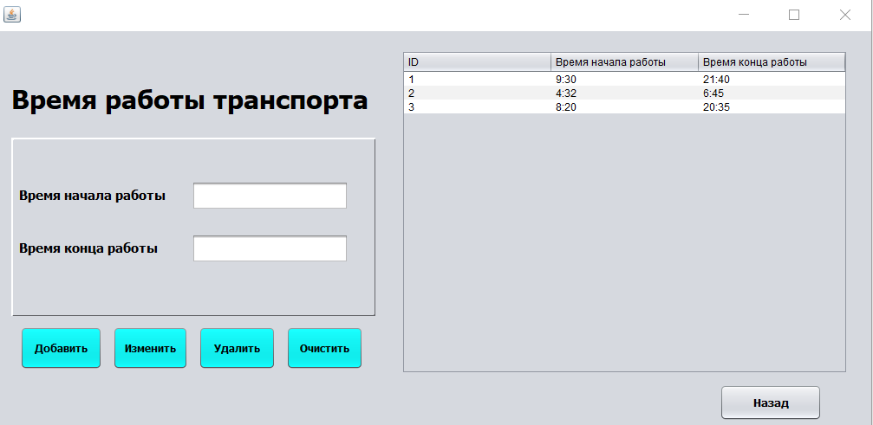

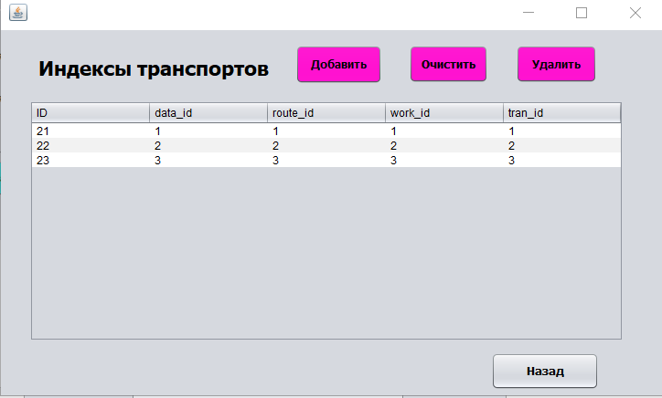

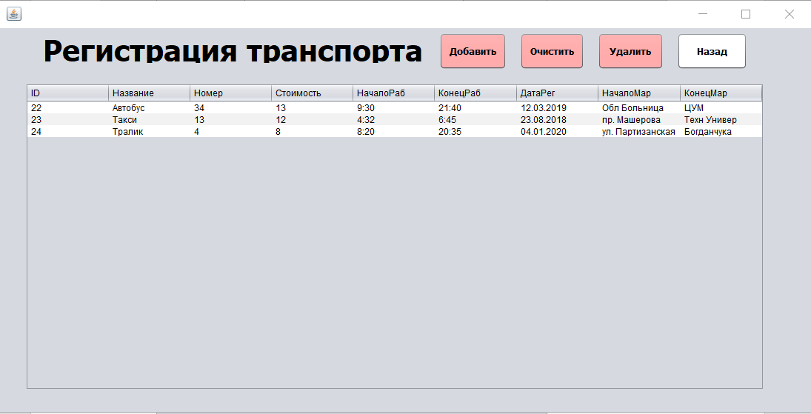

**Вывод:** приобрел практические навыки разработки многооконных приложений на JavaFX для работы с базами данных.